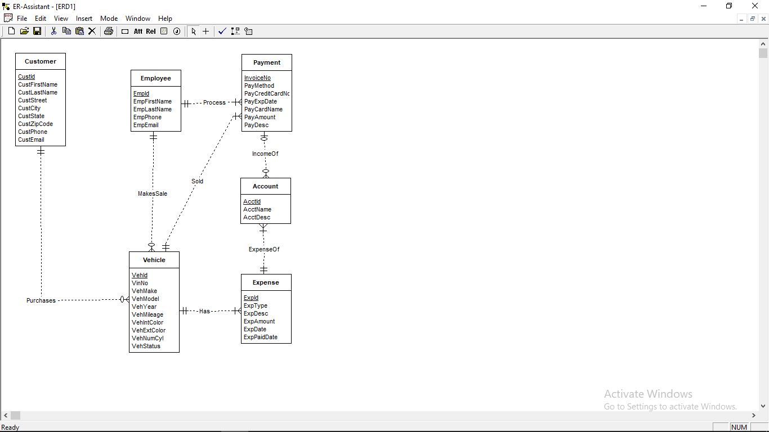



For the given ERD there are no consistency and completeness errors. We can show this by checking the ERD in ER-Assistant.

